# Super Market Sales Analysis Visualization

Name: Sathiya Rubha M

NM Id: au611220104134

**Step 1**: Upload the data

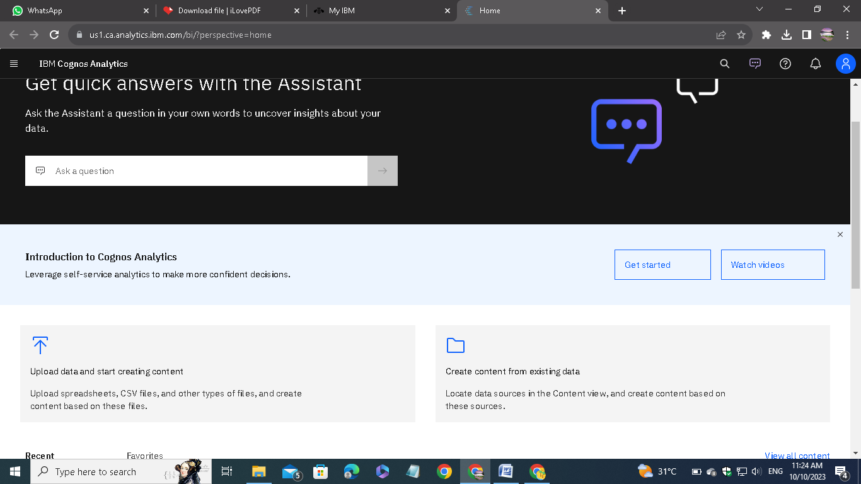

Open IBM cognos Analytics. Then choose upload data.

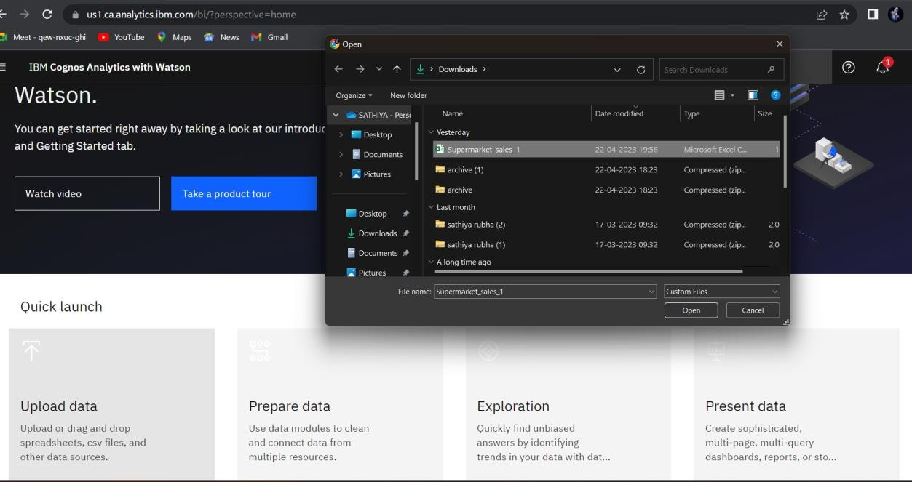

Upload the csv data file which we download from the given link on the assignment.

**Step2**: Preparing the data

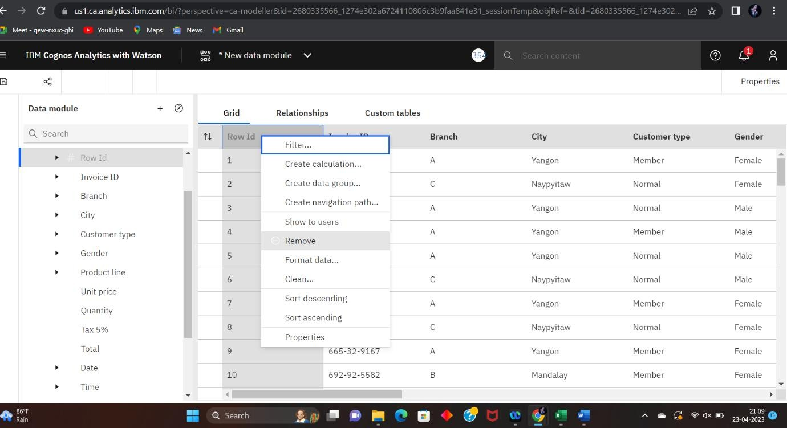

Remove the unnecessary columns and check for the missing values. In my case, there is no missing values.

After removing, save the new data module related to the dataset name.

**Step 3**: Explore the data

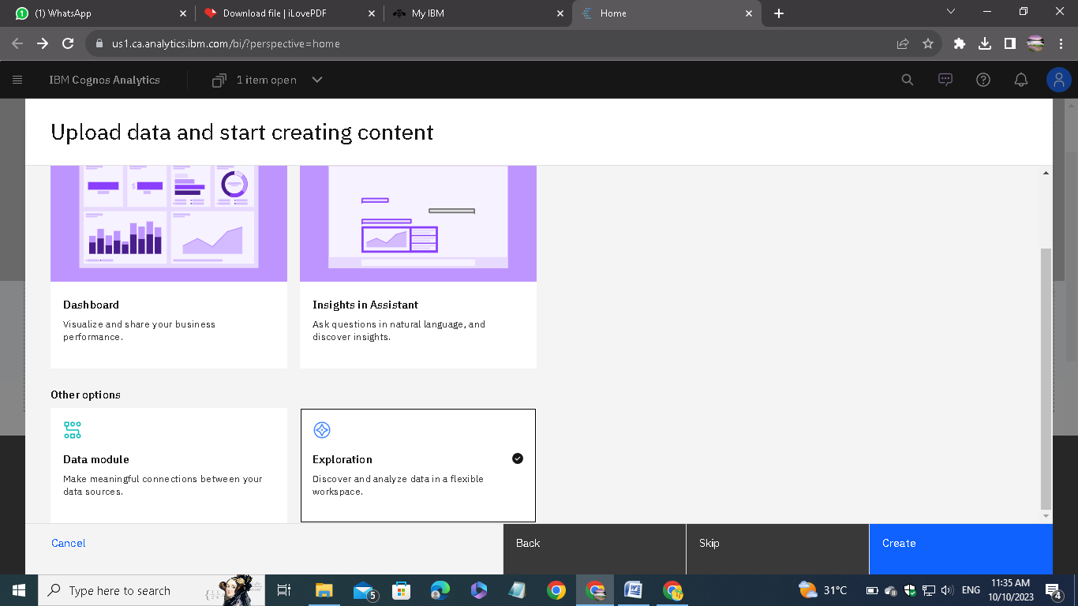

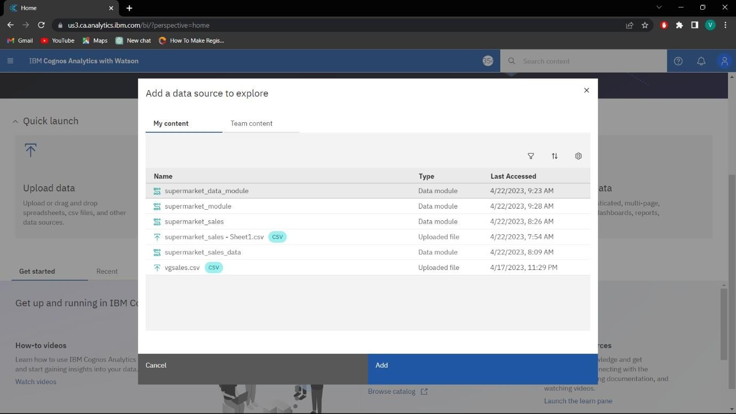

Then Select and add the data module that you want for the exploration.

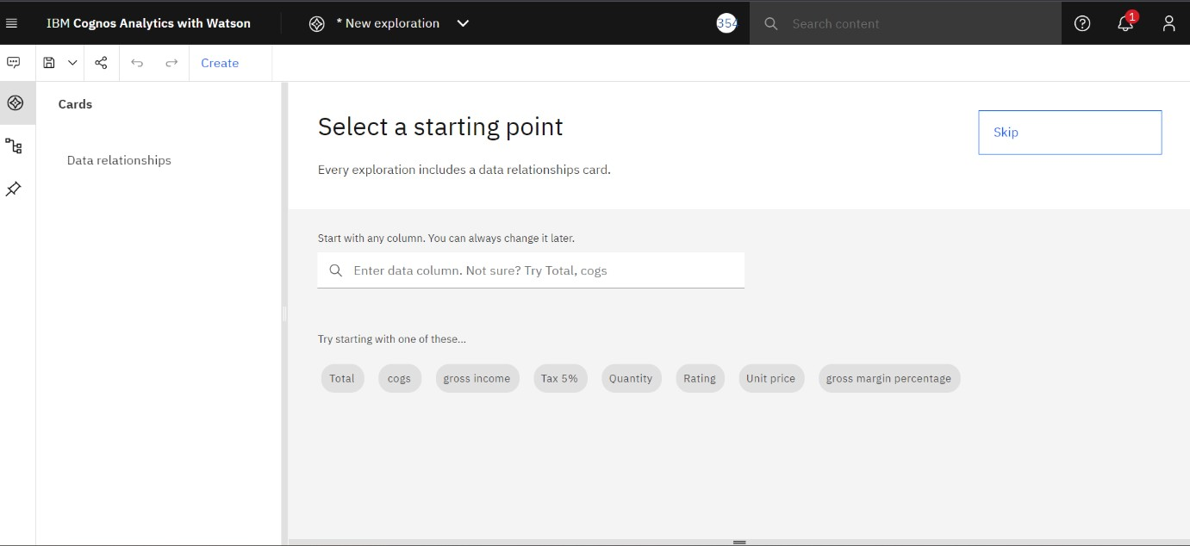

Click on create and select a card style. In my case, I have chosen the single visualization.

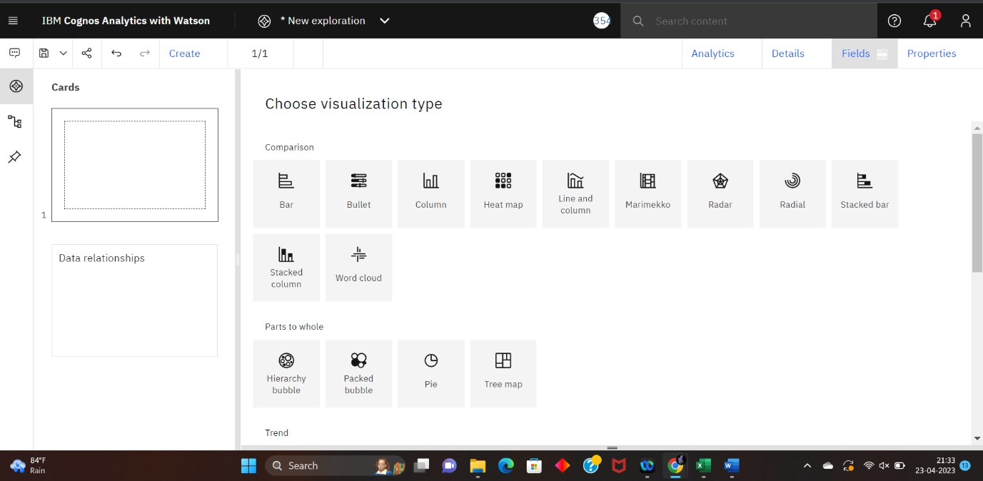

Then choose the type of visualization. Each type of visualization is used for different requirements.

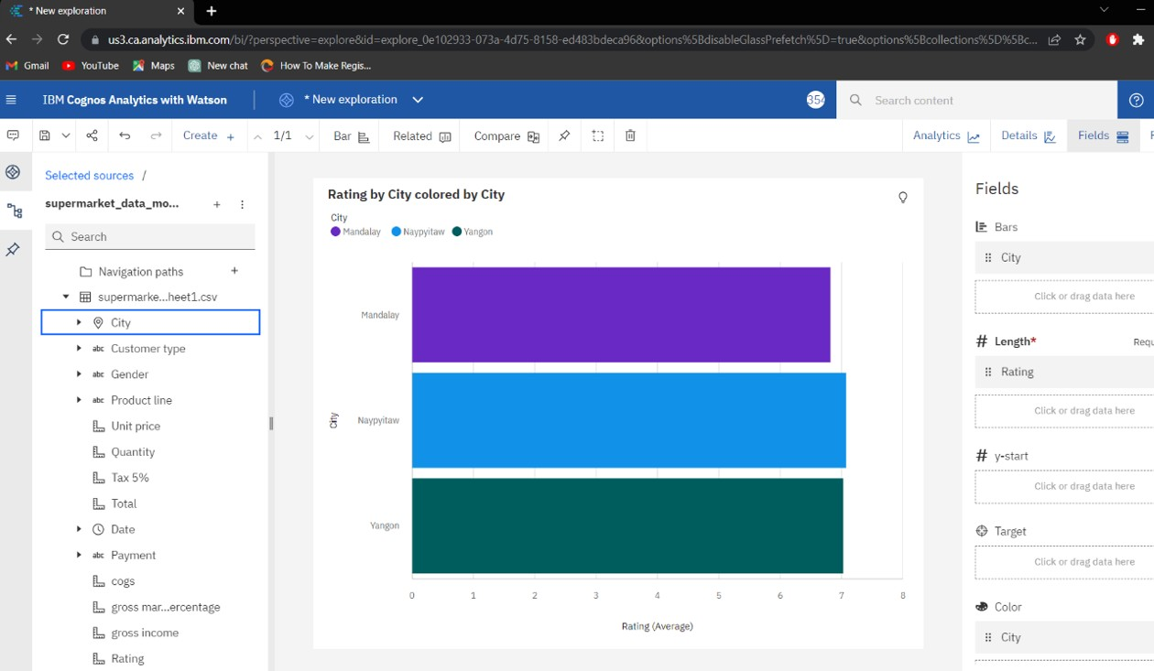

Create the chart using the type of visualization. In the fields, we have to mention the attributes for the x-axis, y-axis and colours.

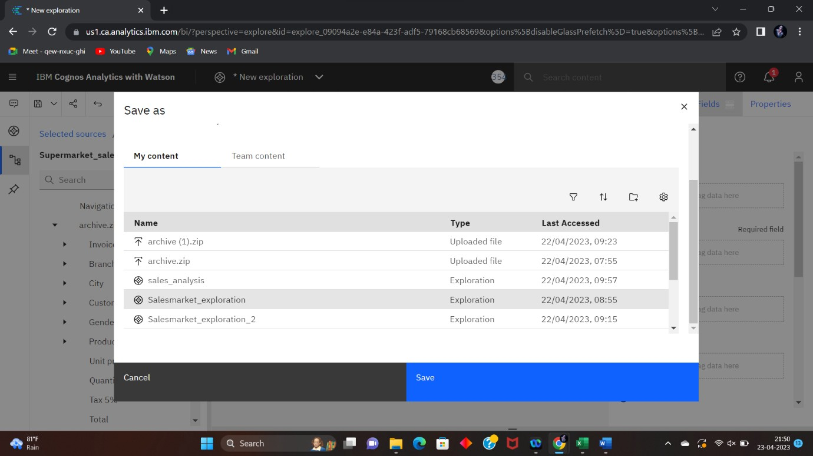

After exploring the data save it in a required name.

**Step 4**: Presenting the data

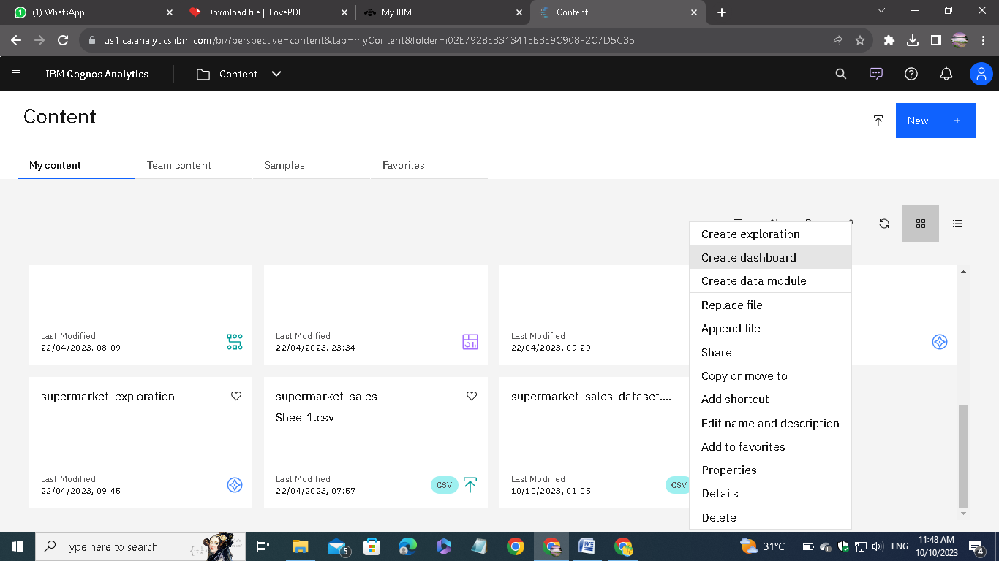

Go to the present data option to visualize the explored data in different format.

Select the type of presentation, in my case I am using dashboard.

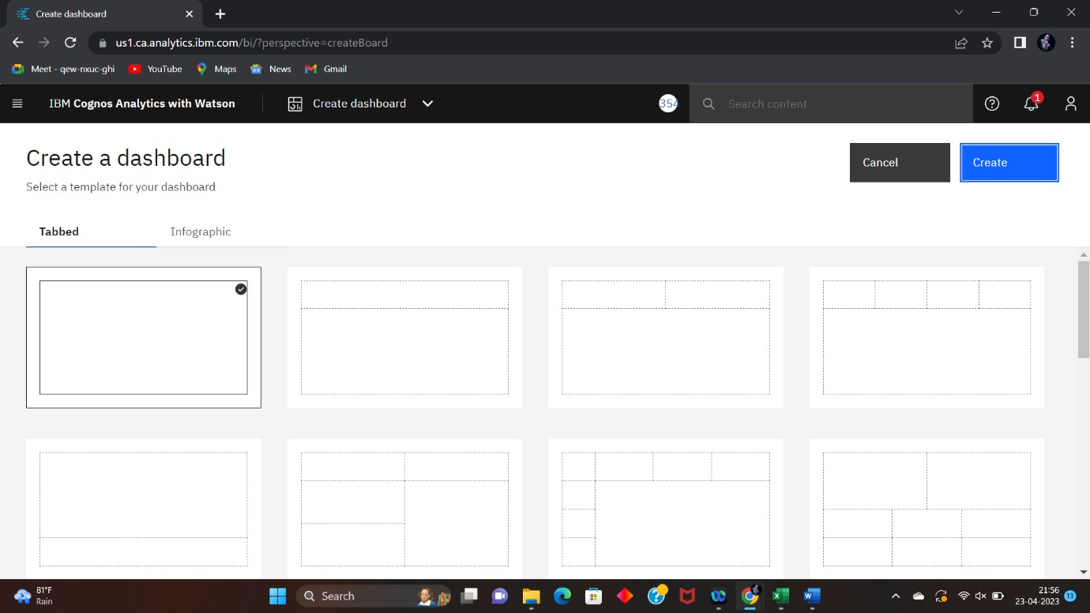

Select the type of dashboard.

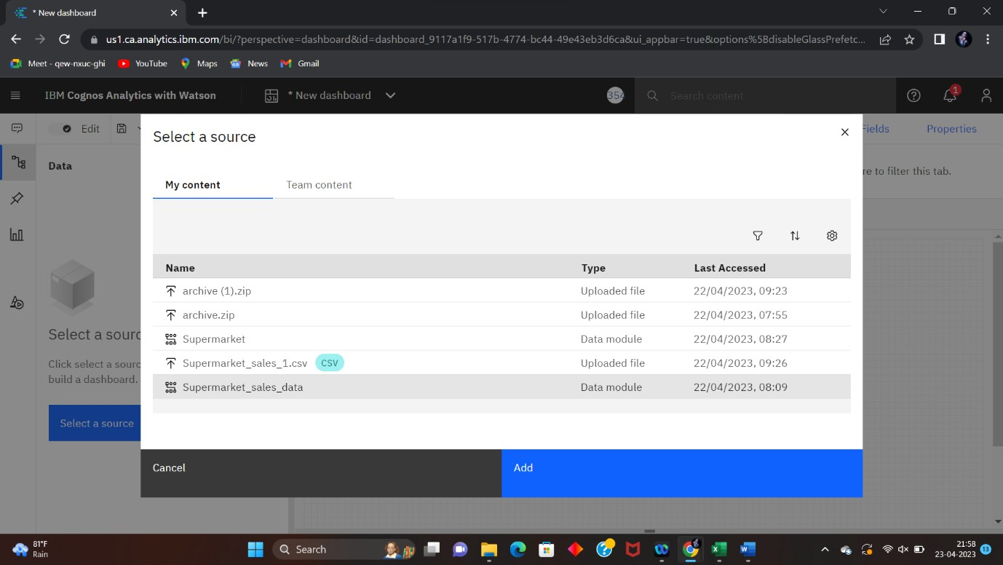

After selecting the type of dashboard click on “select a source” button to add the source file to the dashboard.

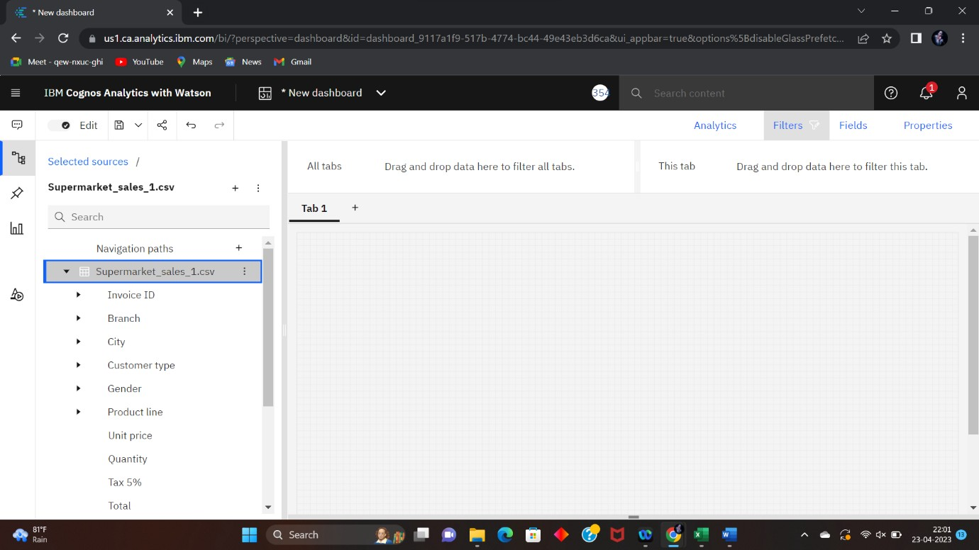

Adjust the dashboard settings for our convenience.

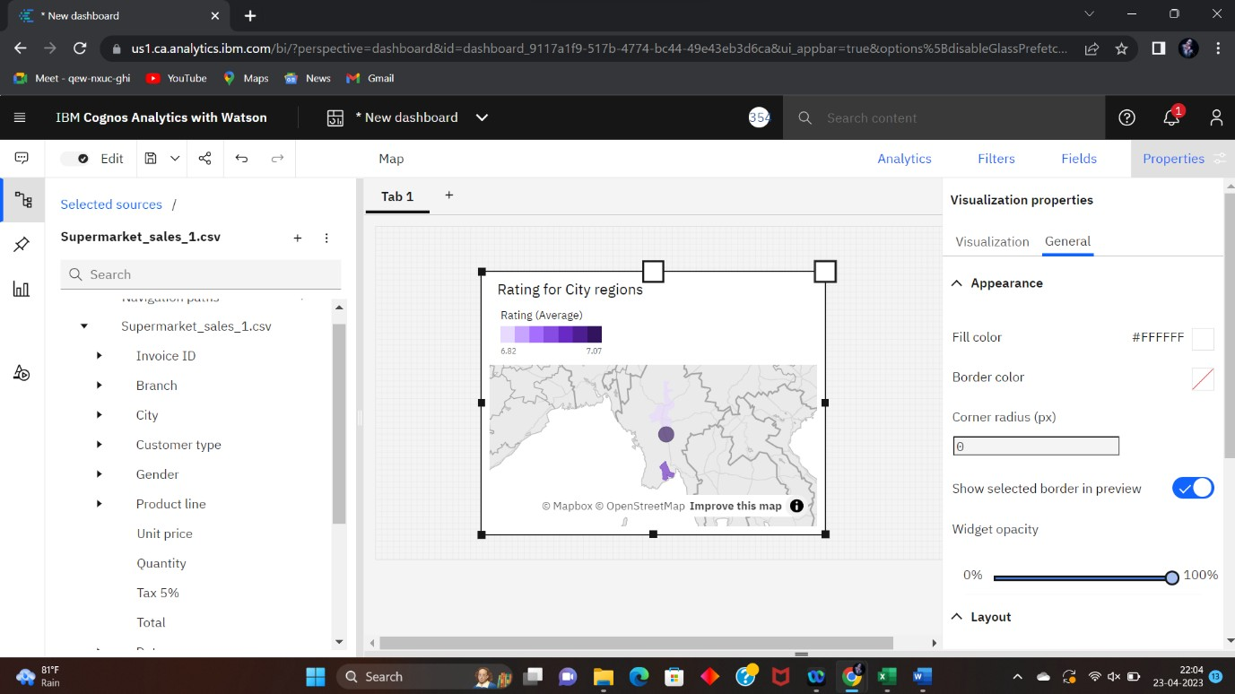

We can able to directly drag the data from the source or we can also able to plot our exploration directly from the pinned things.



Double click on the tab name and change it for our reference.

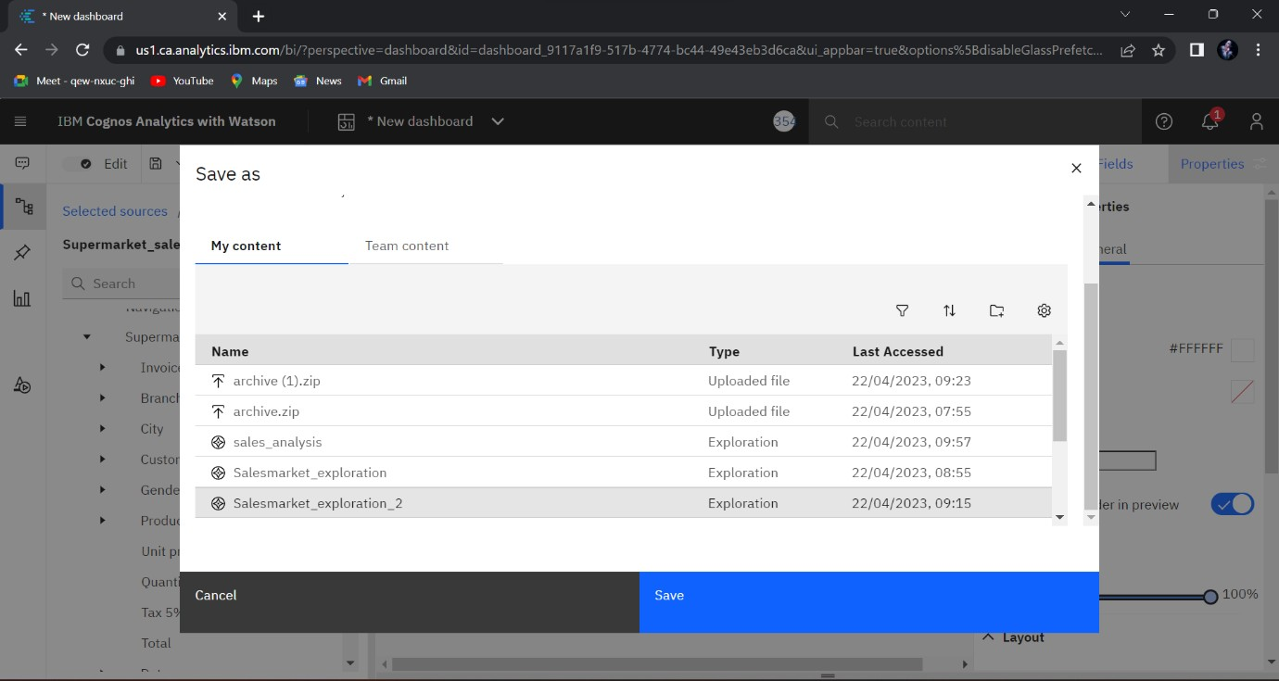

After save the presentation. These steps are followed for all other tabs. Finally we get the visualization of our analytics.

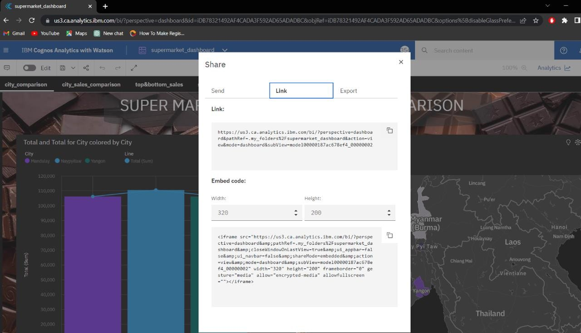

Using share option, we can able to share our presentation direct link or the embed code and through email too.

# Super Market Sales Analysis Visualization

Here I attached the screenshot of all the visualization tabs I created using super market salesdata:

1. Super Market Sales City Wise Comparison

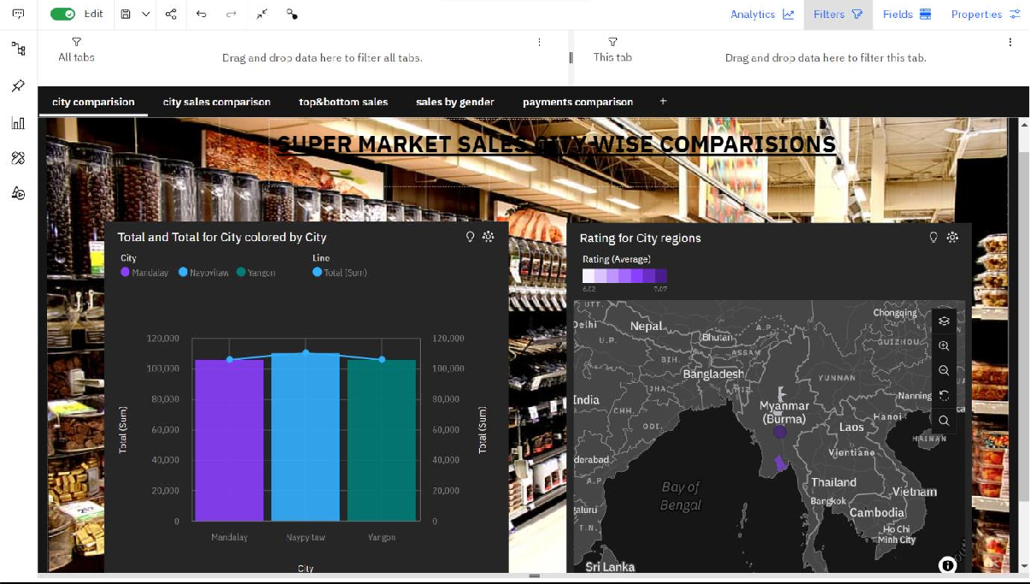

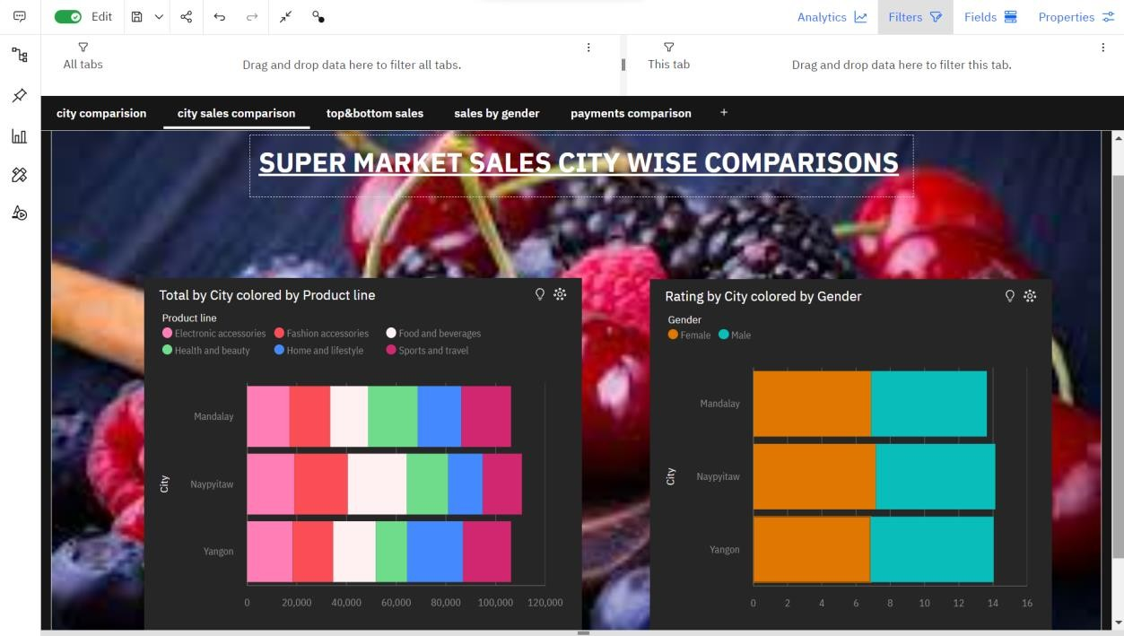

1. Super Market Sales Top 10 & Bottom 10

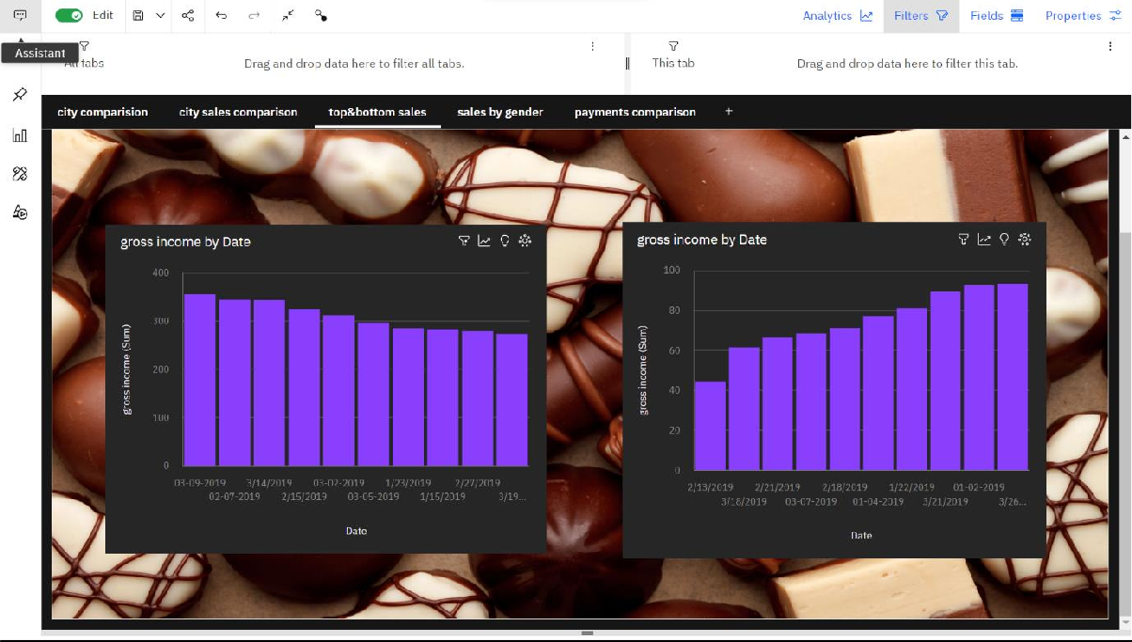

1. Super Market Sales Comparison by Gender

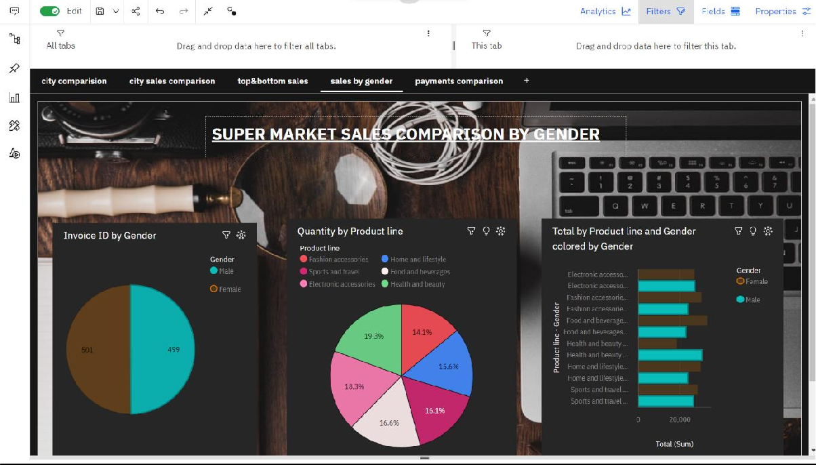

1. Super Market Sales Payment Comparison

